­

2024-25



Vaccination Booking System







Contents

ACKNOWLEDGEMENT 4

INTRODUCTION 5

OBJECTIVES 6

PROBLEM DEFINITION 6

CUSTOMER REQUIREMENT SPECIFICATION 7

E-R DIAGRAMS. 8

PROJECT PLAN 8

ALGORITHMS 9

GUI Standards Document. 9

Interface Design Document 10

Admin Side: 11

All Child Details: 12

Date & time of vaccination: 13

List of vaccinations: 14

Add vaccinations Form: 15

Request from parents 16

Add Hospital 17

Update/Delete Hospital 18

Booking Details: 18

User (As Parent Side): 20

Register & Login 21

Book Hospital 23

My Profile: 23

Hospital Side: 24

Register & Login 25

TASK ALLOCATION 26

PROJECT TEAM

|  |  |  |
| --- | --- | --- |
| **S.NO** | **NAME** | **STUDENT ID** |
| 1 | KIRAN GULL | 1529285 |
| 2 | UZMA GHAFOOR | 1389230 |
| 3 | SADIA MAJEED | 1537722 |
| 4 | UMAIMA AZMAT | 1529007 |

CERTIFICATE OF COMPLETION:



# ACKNOWLEDGEMENT

We begin by expressing our gratitude to Almighty ALLAH, the Most Beneficent and Merciful, who has endowed us with the faculties of thought and emotion, essential for fostering creativity and bringing ideas to fruition. Through His grace and mercy, we were granted the strength and ability to successfully complete this Project.

First and foremost, our heartfelt appreciation goes to our mentor, SIR M. AMJAD, whose unwavering support and invaluable guidance were instrumental in guiding us through this project within the allotted time frame. We also extend our thanks to the other mentors at APTECH LEARNING who provided us with crucial insights and direction throughout the project's development.

The realization of Vaccination Booking System owes its existence to the collaborative efforts, dedication, and support of numerous individuals and resources. Each contribution played a vital role in bringing this endeavor to life.

Lastly, but significantly, we extend our sincere gratitude to the users and visitors of the website. Your interest, feedback, and engagement have been indispensable in shaping the "VACCINATION BOOKING SYSTEM" project. Your interactions motivate us to continually enhance and expand its offerings, ensuring its continued relevance and value.

# INTRODUCTION

The Vaccination Management System project introduces a cutting-edge platform developed using PHP, aimed at streamlining vaccination processes through digital innovation. It creates an engaging, hands-on learning environment by translating theoretical concepts into practical applications. With a phased approach, the project enhances technical skill-building, offering solutions for real-world challenges. By utilizing PHP's flexibility, this system integrates scheduling, tracking, and reporting functionalities, paving the way for efficient vaccine administration management. The project embodies a synergy of collaboration, learning, and problem-solving to provide a meaningful impact in the healthcare domain.

# OBJECTIVES

The Vaccination Management System aimed to redefine healthcare management through the practical application of theoretical concepts. The key objectives included developing a robust, scalable system using PHP to simulate real-world scenarios and streamline vaccination-related processes. Beyond achieving these goals, the project served as a platform to enhance technical proficiency, foster innovation, and encourage independent learning. Its user-centric design simplified complex tasks like scheduling, tracking, and reporting, making vaccination processes more efficient and accessible. This system has been lauded for its significant contribution to bridging technological solutions with healthcare needs, solidifying its status as a milestone project in IT education.

# PROBLEM DEFINITION

The Vaccination Management System was conceived to address inefficiencies in traditional vaccination processes, such as scheduling bottlenecks, error-prone record-keeping, and inadequate communication channels. These challenges often hinder timely vaccine distribution and management. By leveraging PHP and modern database technologies, the project aimed to centralize operations, providing a reliable, automated framework for both administrators and recipients. The system’s ability to generate real-time updates and detailed reports has been widely praised for its impact on reducing administrative burden and human errors. This initiative has successfully showcased how digital solutions can elevate operational standards in healthcare.

# CUSTOMER REQUIREMENT SPECIFICATION

The development of the Vaccination Management System was driven by well-defined customer requirements. Key objectives included implementing role-based access for admins and users, ensuring secure authentication protocols, and maintaining cross-device compatibility. The system incorporated features such as appointment scheduling, vaccination tracking, and notification alerts, addressing both user and administrative needs.

Admins were equipped with tools for managing vaccine inventory, monitoring appointments, and overseeing user data, enhancing operational efficiency. Meanwhile, end-users experienced a seamless and intuitive interface, enabling them to book appointments, receive updates, and track their vaccination history effortlessly.

# E-R DIAGRAMS.

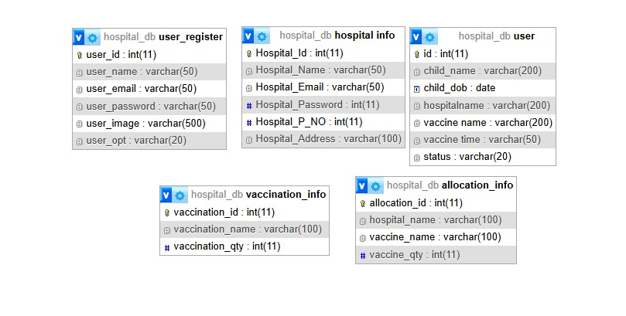

# PROJECT PLAN

The structured project plan was pivotal in achieving timely and successful completion. It encompassed phases like requirement analysis, system design, PHP-based implementation, rigorous testing, and deployment. Milestones such as database schema finalization, user interface development, and module-specific testing were meticulously tracked. Collaboration tools and regular progress reviews ensured seamless coordination among team members. This systematic approach not only aligned with the project’s technical objectives but also highlighted its commitment to quality and efficiency. The plan’s effectiveness was reflected in the system’s final performance, drawing widespread appreciation for its seamless execution.

# ALGORITHMS

The Vaccination Management System’s algorithms showcase exceptional planning and execution, underlining their key role in the system’s functionality. They handle core operations, such as scheduling appointments and updating vaccination statuses, with precision and efficiency. The appointment scheduling algorithm, for example, dynamically checks availability, confirms bookings, and updates records seamlessly in real-time. This design minimizes errors and significantly improves user satisfaction. Furthermore, algorithms for real-time status updates ensure transparent communication, keeping all stakeholders informed. Praised for their clarity and scalability, these algori0074hms highlight the team’s commitment to excellence and set a high benchmark for healthcare technology applications.

# GUI Standards Document.

The Vaccination Management System’s algorithms showcase exceptional planning and execution, underlining their key role in the system’s functionality. They handle core operations, such as scheduling appointments and updating vaccination statuses, with precision and efficiency. The appointment scheduling algorithm, for example, dynamically checks availability, confirms bookings, and updates records seamlessly in real-time. This design minimizes errors and significantly improves user satisfaction. Furthermore, algorithms for real-time status updates ensure transparent communication, keeping all stakeholders informed. Praised for their clarity and scalability, these algorithms highlight the team’s commitment to excellence and set a high benchmark for healthcare technology applications.

# INTERFACE DESIGN DOCUMENT

The interface design of the Vaccination Management System seamlessly combines functionality and aesthetics. Key pages like login, dashboards, and booking forms were designed to ensure clarity and ease of use. Navigation paths were optimized to streamline user interactions, making the system highly accessible. Feedback-driven improvements further enhanced the design, aligning it with best practices and accessibility standards. The interface has been praised for its role in making the system intuitive and efficient, contributing significantly to its success and user satisfaction

# ADMIN SIDE:

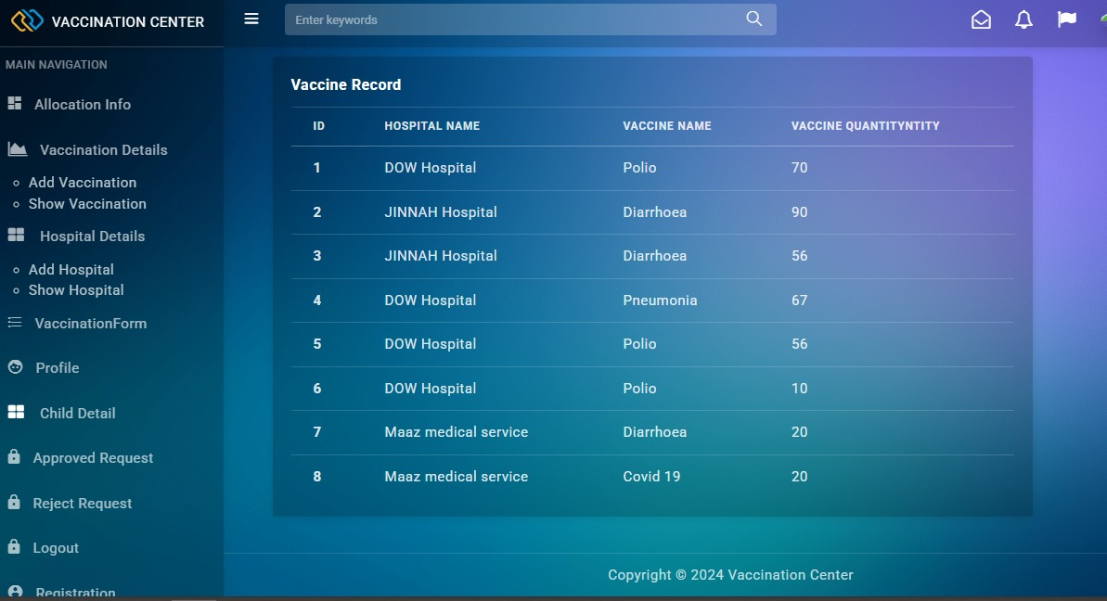

* This Image of the Web Containing the View of Index Page of Admin Panel of Vaccination Booking System When Admin will sign in they can see.
* In Sidebar there are main navigations of the web (As per Requirements)
  + All child details
  + Date & time of vaccination
  + Report of vaccination
  + Child, Vaccination (Date wise report)
  + List of vaccine
  + available or unavailable
  + Request from parents
  + Approve or Reject
  + Add Hospital + Add Vaccinations
  + Update/Delete Hospital + Update/Delete Vaccinations
  + List of hospitals + List of Vaccinations
  + Booking Details

# ALL CHILD DETAILS:

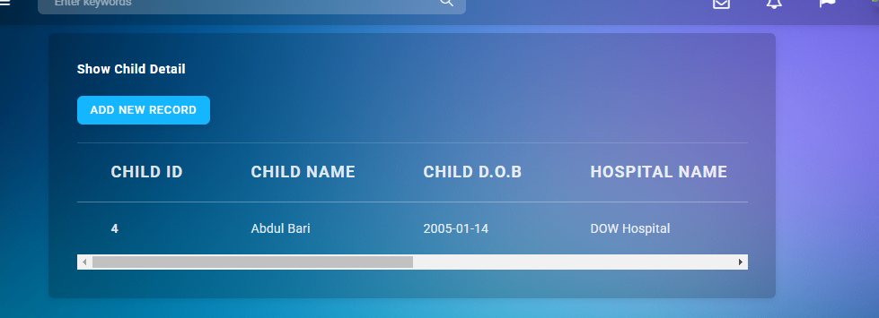

* Admin can manage All child Details From here.

# DATE & TIME OF VACCINATION:



# LIST OF VACCINATIONS:

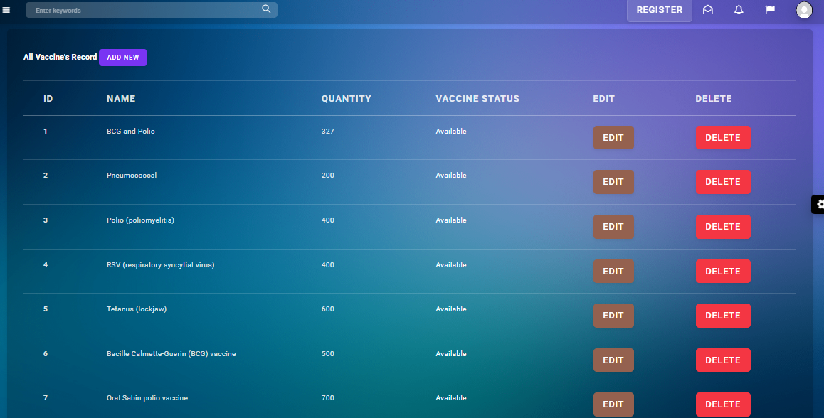

* Admin can view the availability of the vaccination. Also Admin can insert new record of Vaccination Through a form (Add Vaccination) that new Record will be stored in Database (MySQL).
* Admin can Update and Delete the Vaccination Data.

# ADD VACCINATIONS FORM:

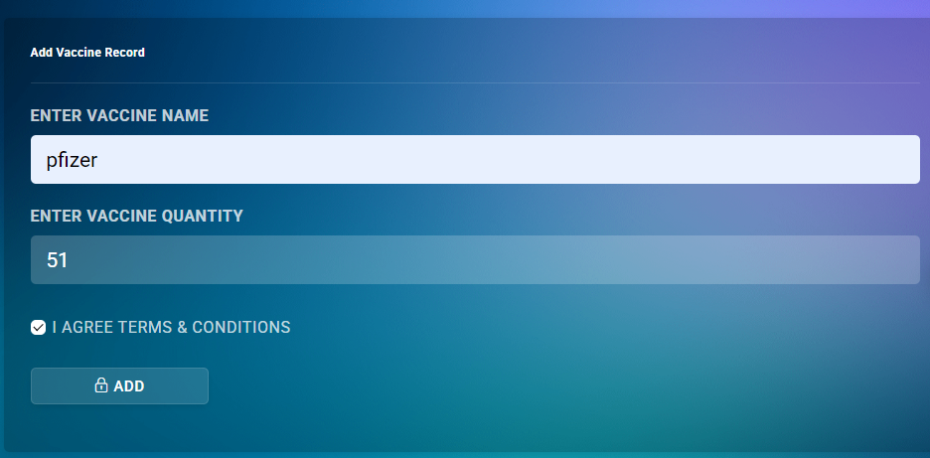

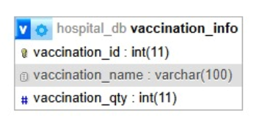

# REQUEST FROM PARENTS

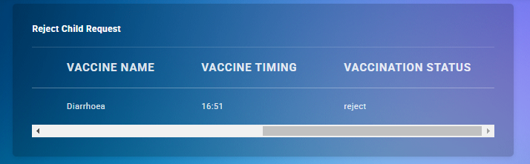

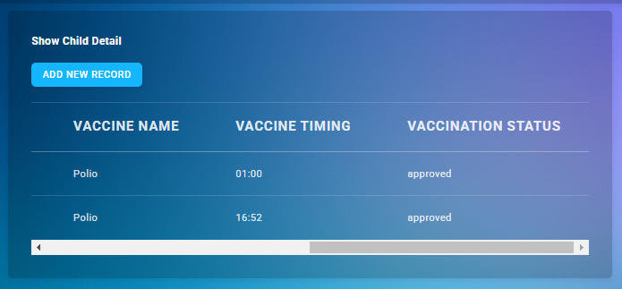

* Approve or Reject
* Once the request for appointment from parent side, it will be approved from the admin.

# ADD HOSPITAL

­­ 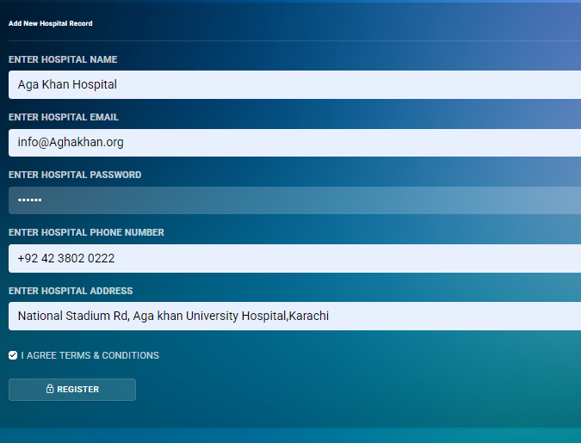

* Admin can Add Hospitals through form. And data Will stored in Database (MySQL).

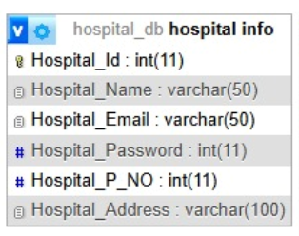

# UPDATE/DELETE HOSPITAL

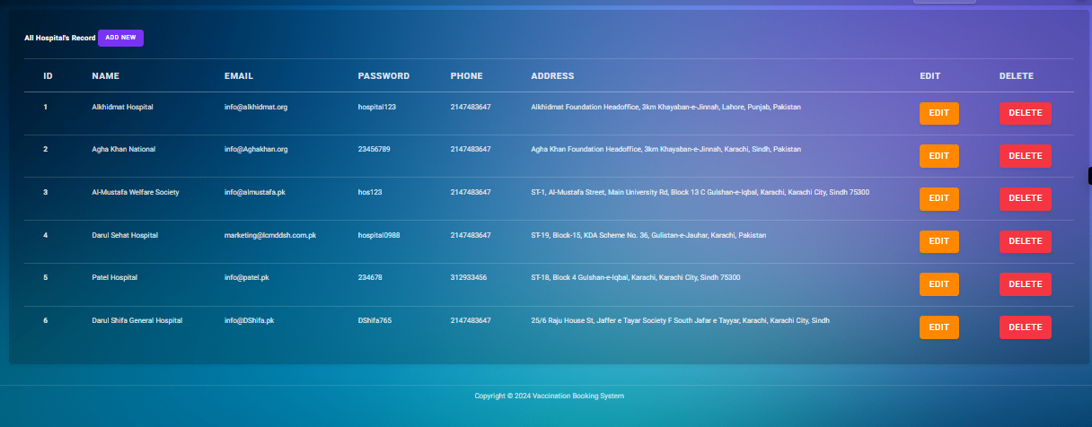

* Admin can view the List of registered hospitals. Also Admin can update and delete the record of Hospitals through the button shown in list and that updated Record will be stored in Database (MySQL).

# BOOKING DETAILS:

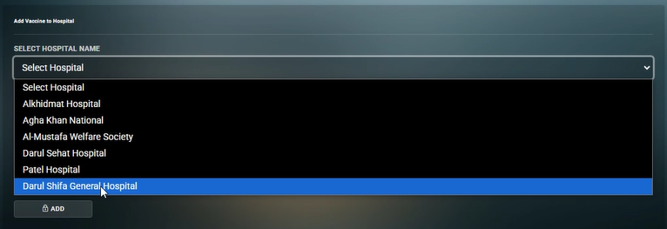

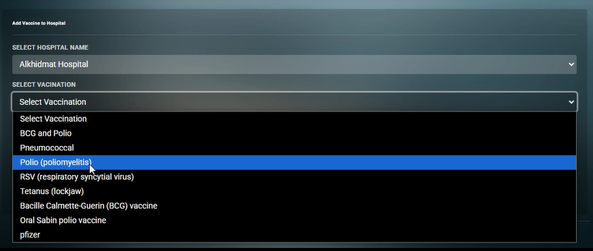

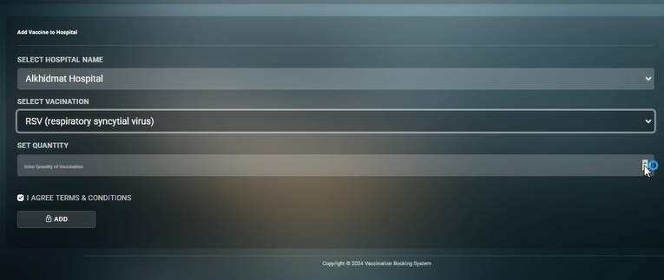

* This data will also Store in Database (MySQL) and will show on Index Page.

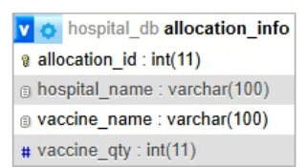­­­

# User (As Parent Side):

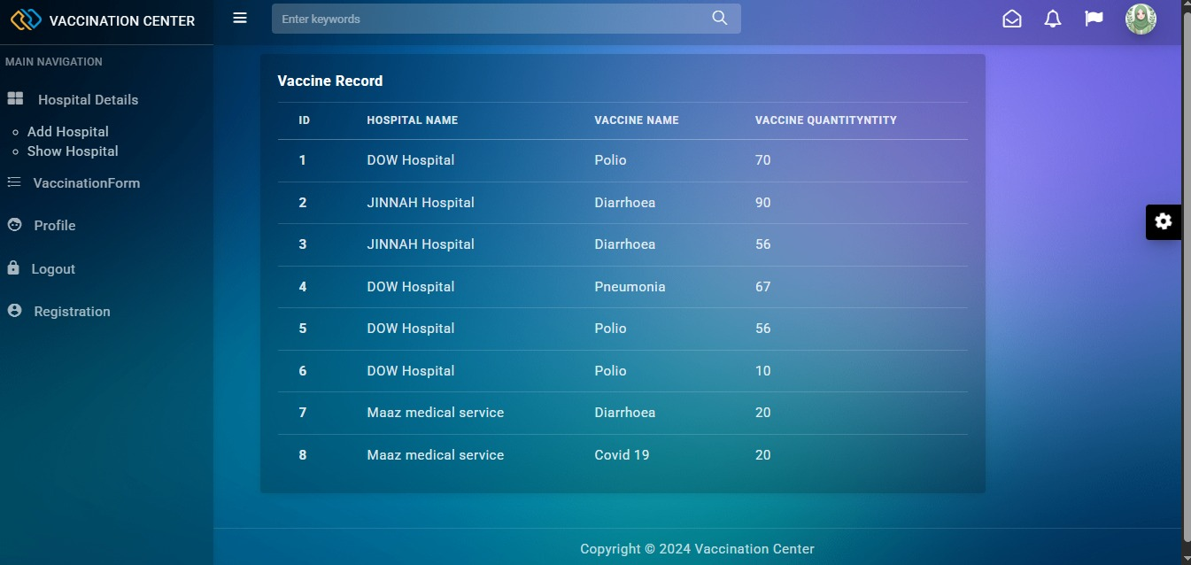

* This Image of the Web Containing the View of Index Page User (As Parent) of Vaccination Booking System. When User (parent) will sign in they can see.
* In Sidebar there are main navigations of the web (As per Requirements)
  + Register & Login
  + Details of child
  + Vaccination Dates
  + Book Hospital
  + Request for hospital
  + Report of vaccination taken
  + My profile

# REGISTER & LOGIN

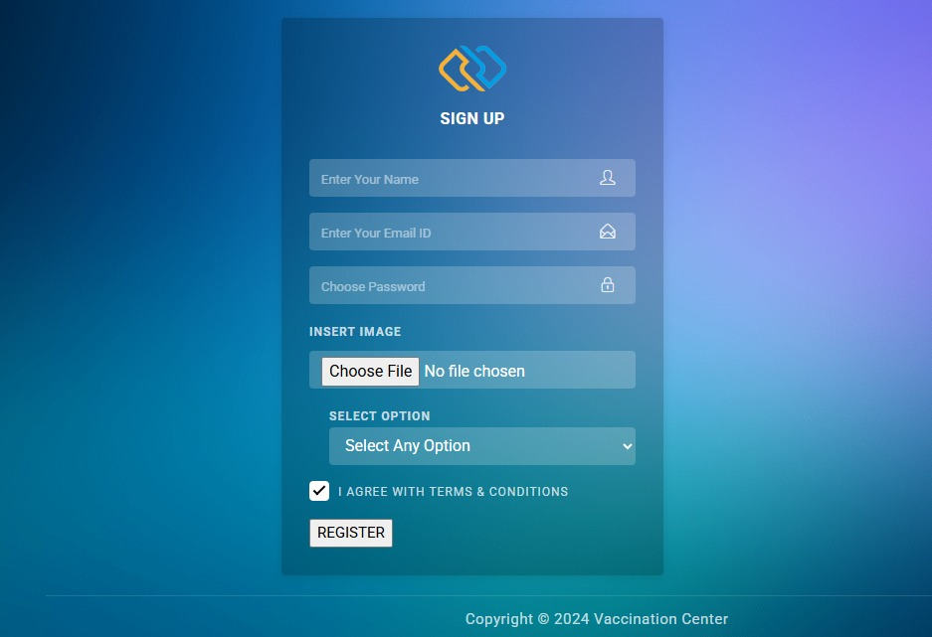

* Here new User (parent) will register by fill this form. Then data will store in Database (MySQL).

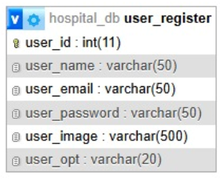

* Then User have to sign in by filling the form below.

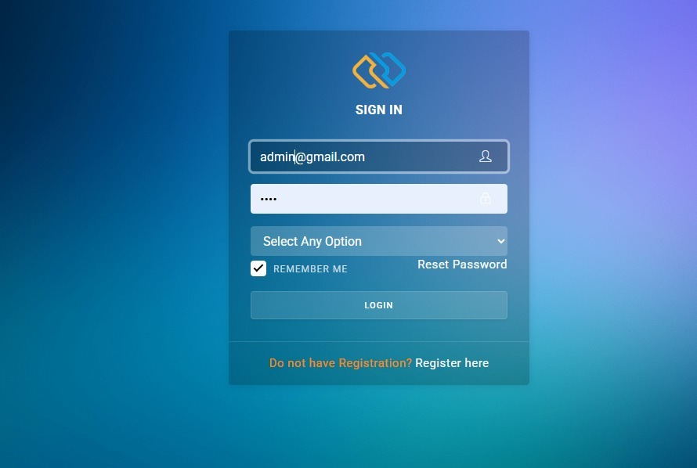

* But when an Admin Wants to sign up it has static email and password as shown in image.

# BOOK HOSPITAL

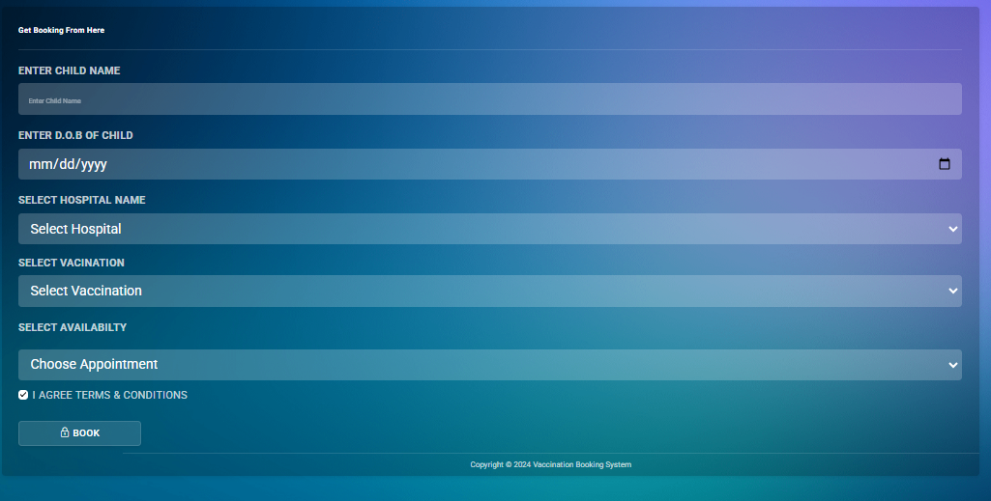

* By filling this form. User will get the booking of hospital and vaccination with dates and time.
* Then Request will gone pending until Admin will approve or Reject the Request.

# MY PROFILE:

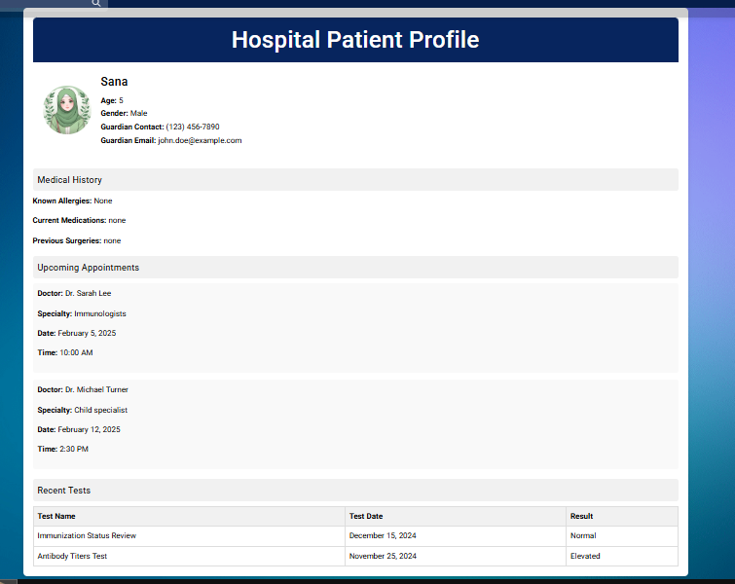

* Profile page of web When User will Sign in this web it redirect on profile page. Where User could see the Medical History and upcoming Appointments.

# HOSPITAL SIDE:

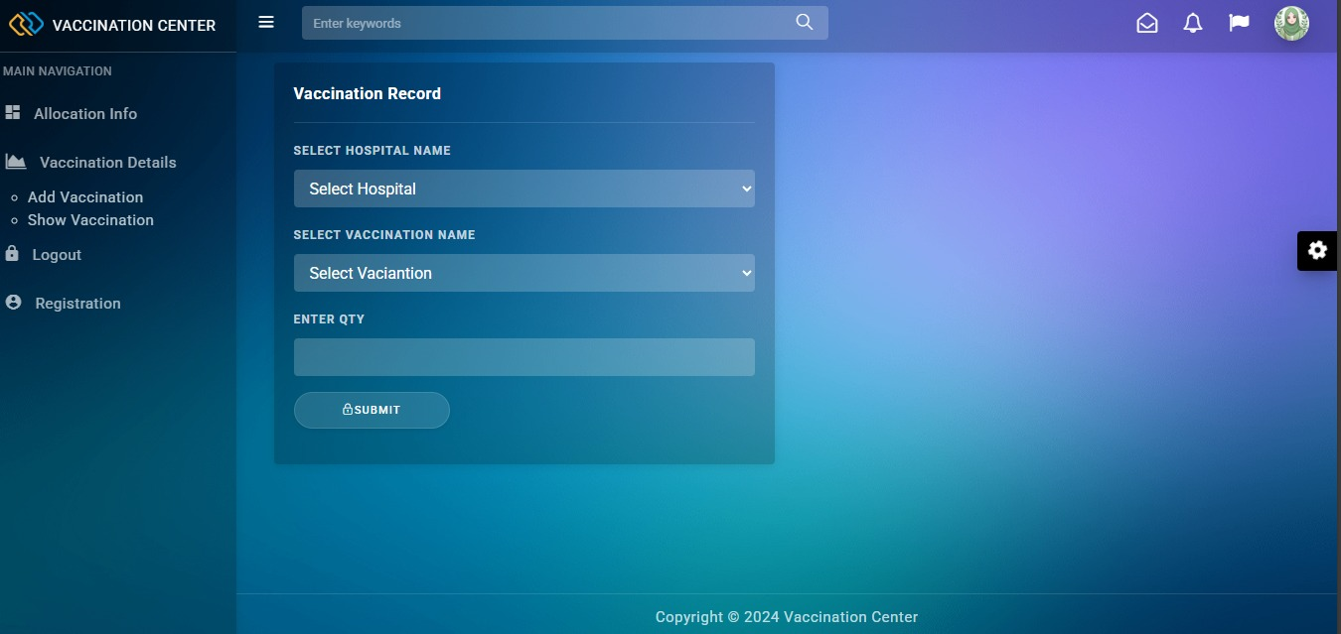

* This Image of the Web Containing the View of Index Page of Hospital Side of Vaccination Booking System. When Hospital will sign in they can see
* In Sidebar there are main navigations of the web (As per Requirements)
  + Register And Login
  + Status of vaccination

# REGISTER & LOGIN



* Here new User (Hospital) will register by fill this form. Then data will store in Database (MySQL).

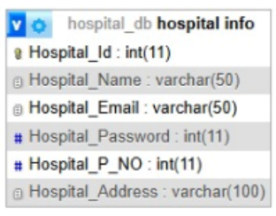

* Then User (Hospital) have to sign in by filling the form below.



* But when an Admin Wants to sign up it has static email and password as shown in image.

# Update Vaccine status:

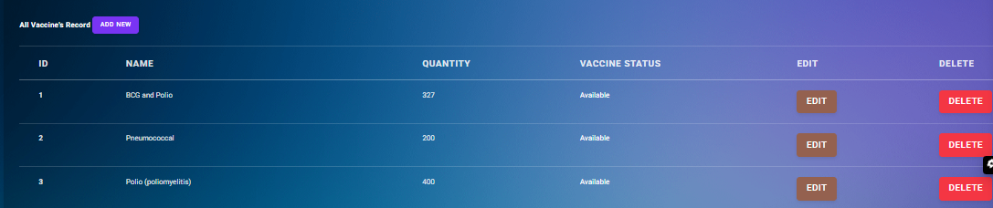

* Hospital will receive the appointment once its booked from admin side. If vaccination is completed they will update the status to Vaccinated or not.

TASK ALLOCATION

ACTIVITY & PLAN

PREPARED BY:

|  |  |  |  |  |  |  |
| --- | --- | --- | --- | --- | --- | --- |
| **Project Ref No:** | | **Title** | DATE OF PRAPERATION | **OF ACTIVITY PLAN** | | |
| S.NO | TASK | Vaccination Booking System | ACTUAL  START DATE | Approx. End Date | TEAM MEMBERS NAMES | STATUS |
| 1 | Project plan | 10 Dec 2024 | 10/12/24 | KIRAN, UZMA , SADIA , UMAIMA | OK |
| 2 | Admin Panel | 10/Dec/2024 | 2/1/25 | UZMA GHAFOOR | OK |
| 3 | Parent Side | 10/Dec/2024 | 2/1/25 | KIRAN GULL | OK |
| 4 | Hospital Side | 10/Dec/2024 | 2/1/25 | UMAIMA­­ | OK |
| 5 | (Sidebar) Views Adjustments | 20/Dec/2024 | 2/1/25 | SADIA MAJEED | OK |
| 6 | Documentation | 3/Dec/2024 | 4/1/25 | KIRAN GULL | OK |
| 7 |  |  |  |  |  |

# Hardware/ Software Requirements

1. Hardware

* A minimum computer system that will help you access all the tools in the courses is a Pentium 166
* 64 Megabytes of RAM or better
* 128 Megabytes of RAM or better

1. Operating System

* Windows 2000 Server Software
* PHP
* MySQL
* Apache